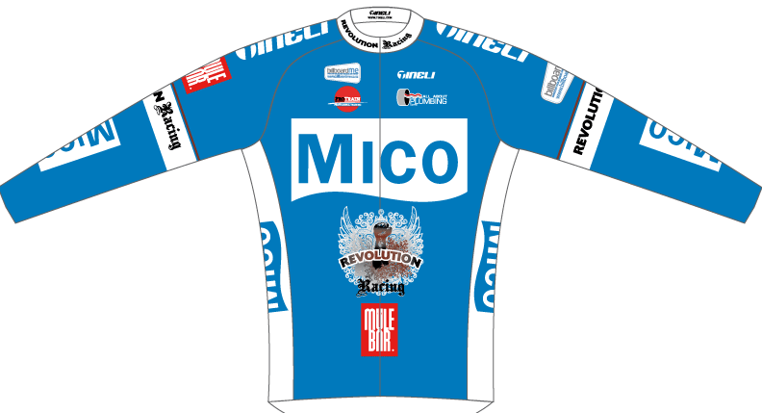
Cycling Team Mico-Revolution Racing, Ready For Action.

Team Mico-Revolution Racing have today announced their schedule and new additional riders for next month. The team which now adds National points series winners, Hawkes Bay’s Jeremy Yates and partner Serena Sheridan, to the roster, will kick off the year in Nelson at the Tour de Vineyards from the 1-4th January. Joe cooper and Jeremy Yates will team up to fine tune their preparations for the Elite Nationals, as will Serena in the woman’s grade. Make no mistake; it won’t be a fun training ride for the team or the other competitors, as they will look to support each other to take the titles and stage honours over the 4 days of tough Nelson racing.
A few days later, the Mico-Revolution Racing moves on and lines up at the NZ Elite Champs in Christchurch with a very strong team to contest for the titles. Matt Wheatcroft is itching to line up in the U23 Time Trial on the first day of racing and Serena Sheridan is focused and capable of the win she wants in the woman’s Elite Championships, on the second day of action. The third and final day of action will be the combined U23 Men’s and Elite Men’s road race.
Team Mico-Revolution Racing are ready with a top squad under the guidance of managers Steve Elden and Richard Aitken, who know that a team that works well together, wins together. Having a “star team” rather than a “team of stars” is something that Elden believes can beat the best Pro riders in NZ. Elden is confident that with Wellington’s Joseph Cooper, Cambridge’s Brad Carter and now NZ point series winner and former World Junior Road Champion Jeremy Yates all pulling on the new colours of Team Mico-Revolution riding in the Elite men’s race and working together as one unit, wearing the National jersey for the year becomes a very real concept. It’s a mint, well – balanced team that has been put together. When asked, “Which one is the leader?” Elden comments that the key is that everyone can play their many cards and back it up so that there are three heavy duty options with a course that favours our riders.” He continues, “I’m looking forward to this race in Christchurch. All the riders are motivated to assist and win and all have an equal opportunity to take the jersey proudly to Europe this year as they join up with their European teams later this summer. We also have a fourth option, Matt Wheatcroft in the same race as part of the team and he is in the U23 category, so he will get support to help win the title, in what is also a very important win.
Following the South Island events, the team moves on to a training phase in the North Island with the Hub Cycles Tour in Hawkes Bay and the Trust House Tour of Wellington, the next focus for the team. Look out for the team wearing the new colours at the Elite Champs in Christchurch on the 7th, 8th & 9th Jan 2011.
For more info contact Team Director Steve Elden 027 477 8673

